1 )
An Assessment of Maharashtra State Health System

The assessment of the Maharashtra State Health System provides a comprehensive overview of the current state of health services in Maharashtra, highlighting both achievements and challenges. Here’s a detailed summary based on the contents of the document:

Overview
Maharashtra is recognized as one of India's largest and most industrialized states, with a significant population. Despite improvements in health status over the years, the state faces substantial interdistrict disparities and challenges in keeping pace with national health improvements.

Key Findings
- Health Status and Disparities:
  - Maharashtra traditionally has a better health status compared to the national average, but recent trends show that improvements are lagging behind the national pace.
  - There is a notable burden of noncommunicable diseases (NCDs) alongside emerging infectious diseases, necessitating a robust health system to address both.
- Public Health System Challenges:
  - The public health system is experiencing stagnation due to inadequate financial resources and systemic deficiencies.
  - The proportion of patients seeking inpatient care in government hospitals has significantly decreased, from 44% in 1986/87 to only 20-26% between 2014 and 2018 in rural areas.
  - There is a severe shortage of secondary-level public hospital services in rural areas and a lack of primary health centers in urban settings.
- Infrastructure and Service Quality:
  - Existing public health facilities are deficient in various aspects, including infrastructure, service quality, and preparedness for public health emergencies.
  - Systemic interventions are required to enhance service quality and public health preparedness.
- Human Resource Management:
  - The report discusses the need for a comprehensive Human Resource Management System (HRMS) to better manage health personnel, including regular and contractual staff.
  - The new HRMS aims to provide a holistic view of human resources, covering all aspects from recruitment to pensions.

Recommendations
- Strengthening the health system to address both communicable and noncommunicable diseases.
- Enhancing financial investments in public health infrastructure to meet national norms.
- Implementing systemic reforms to improve the quality of health services and ensure better access for rural and urban populations.
- Developing a comprehensive HRMS to improve the management of health personnel and ensure efficient service delivery.

Conclusion
The assessment underscores the urgent need for reforms in the Maharashtra State Health System to address existing gaps and improve health outcomes. It calls for a collaborative effort among government agencies, health professionals, and the community to revitalize the public health infrastructure and enhance service delivery.
This summary encapsulates the critical insights and recommendations from the assessment, emphasizing the need for strategic interventions to strengthen the health system in Maharashtra.

The data processing for the assessment of the Maharashtra State Health System involved several steps and methodologies, as outlined in the document. Here are the key aspects of how the data was processed:
- Field Visits and Data Collection:
  - Initially, the assessment planned for field visits to gather firsthand data from various health facilities across Maharashtra. However, due to the emergence of the COVID-19 pandemic in March 2020, these visits were canceled.
  - Instead, the assessment relied on secondary data available in the public domain, which included existing reports, health statistics, and other relevant documents.
- Collaboration with Experts:
  - The assessment involved collaboration with various experts and officials from the health department. For instance, insights were gathered from T. P. Lahane, Director of Medical Education and Research, regarding medical education and the establishment of new medical colleges.
  - Data on healthcare facilities and public health information was provided by Nitin N. Ambadekar, Joint Director (Hospitals and Procurement).
- Training Performance Data:
  - Consolidated training performance data for training institutions in the Public Health Department was shared by Umesh Navade, Principal Public Health Institute, Nagpur. This data was crucial for understanding the capacity and effectiveness of health workforce training.
- Claims Data Analysis:
  - The assessment also included analysis of claims data related to the Pradhan Mantri Jan Arogya Yojana (PMJAY) and the Maharashtra government's health insurance scheme (MJPJAY), with assistance from Ravish Behal.
- Acknowledgment of Contributions:
  - The report acknowledges the contributions of various individuals and public authorities who provided data and insights throughout the assessment process. This collaborative approach helped ensure a comprehensive understanding of the health system.
- Data Processing Challenges:
  - The document notes that the process for the release of National Health Mission (NHM) funds was complex, involving multiple departments and units within the Maharashtra Public Health Department (PHD). Although the process was simplified in 2016/17, it remained cumbersome, which could affect data availability and processing efficiency.
Overall, the assessment utilized a combination of secondary data analysis, expert insights, and collaborative efforts to process and compile the information necessary for evaluating the Maharashtra State Health System.

Table 1: Area, Population, and Per Capita Income of Maharashtra and Selected States

State | Area (km²) | 2011 Census Population | PCI at Current Prices ($) FY2016 | PCI at Current Prices ($) FY2017 | PCI at Current Prices ($) FY2018 | Growth Rate at 2011/12 Prices (%) FY2016 | Growth Rate at 2011/12 Prices (%) FY2017 | Growth Rate at 2011/12 Prices (%) FY2018
Karnataka | 191,791 | 61,095,297 | 2,262 | 2,537 | 2,911 | 11.08 | 13.34 | 10.13
Gujarat | 196,244 | 60,439,692 | 2,127 | 2,330 | 2,685 | 10.23 | 9.71 | 11.05
Maharashtra | 307,713 | 112,374,333 | 2,234 | 2,415 | 2,732 | 7.2 | 9.21 | 7.54
Kerala | 38,852 | 33,406,061 | 2,263 | 2,479 | 2,846 | 7.44 | 7.56 | 7.27
Telangana | 112,077 | 35,003,674 | 2,151 | 2,376 | 2,800 | 11.58 | 9.34 | 10.15
Tamil Nadu | 130,060 | 72,147,030 | 2,145 | 2,300 | 2,662 | 8.24 | 7.15 | 7.68
Madhya Pradesh | 308,252 | 72,626,809 | 956 | 1,115 | 1,287 | 9.09 | 12.45 | 6.19
All India | 3,287,469 | 1,210,854,977 | 1,448 | 1,564 | 1,789 | 8 | 8.3 | 7

FY = fiscal year, km2 = square kilometer, PCI = per capita income.
Notes:
1. Area and population data from Statistical Yearbook 2018.
2. Area and population data of Telangana from Government of Telangana (2017).
3. PCI and growth rate data from Tables 10–12 in CSO Data.
4. to $ rates for respective fiscal years are from Table 140 in Handbook of Statistics on the Indian Economy, 2019–20.
Source: Government of India, Ministry of Statistics and Program Implementation. Statistical Yearbook 2018. http://mospi.nic.in/
statistical-year-book-india/2018/; Government of Telangana. 2017. Telangana State at a Glance. https://www.telangana.gov.in/
PDFDocuments/Telangana-state-at-a-glance-2017.pdf; Government of Punjab, Economics and Statistics Organization.
https://www.esopb.gov.in/static/PDF/GSDP/Statewise-Data/statewisedata.pdf accessed 12 April 2020); Reserve Bank of India.
2020. Handbook of Statistics on the Indian Economy, 2019-20. Mumbai.

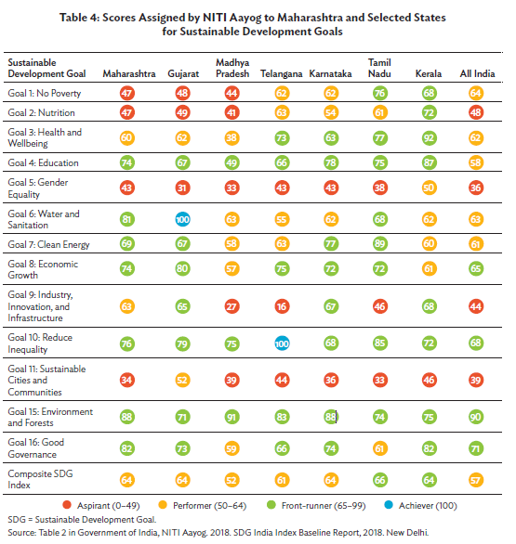

Key Takeaways
(i) Maharashtra is the largest economy, second most populous and third largest state in India.
Maharashtra is also one of the most industrialized and urbanized states in the country.
(ii) Although the legacy of regional imbalance in socioeconomic development has reduced
to some extent, substantial interdistrict disparities remain. The Human Development
Index of Maharashtra ranks sixth among the states and its Sustainable Development
Goals index score is average.
(iii) Gender inequity and haphazard urbanization result in a host of interrelated environment
and health hazards, especially for the urban slum dwellers.
(iv) Any plan to strengthen the health care system in Maharashtra has to prioritize underserved
areas, sustainable urbanization with built-in public health care infrastructure, and special
needs of women and children.

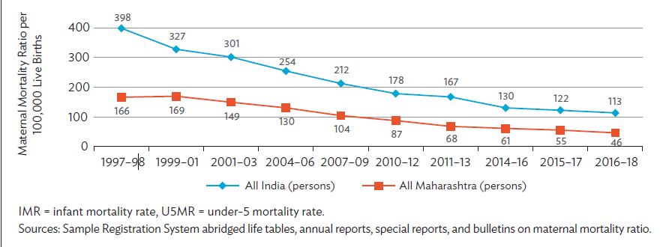

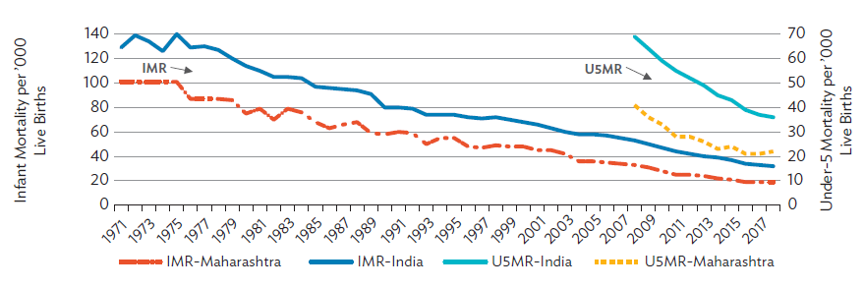

Burden of Disease in Maharashtra
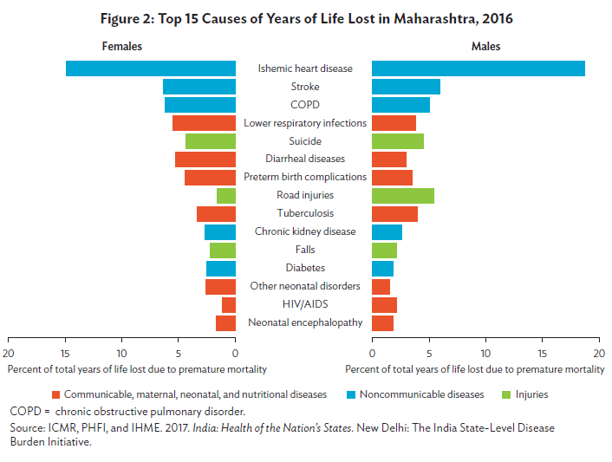
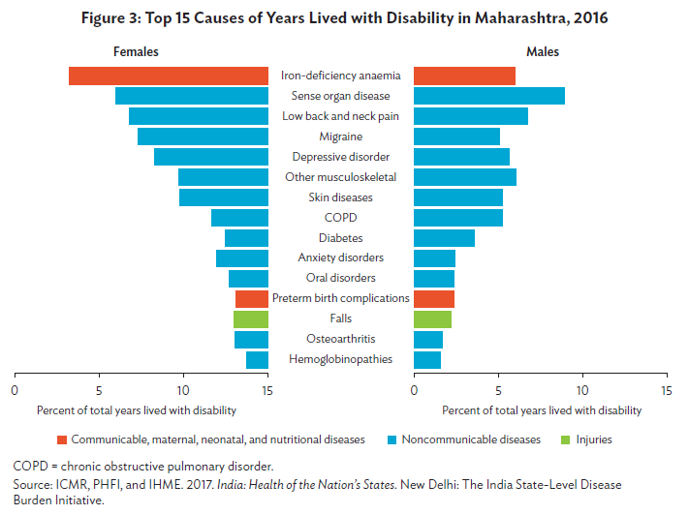

Communicable Disease Outbreaks in Maharashtra and the COVID-19 Pandemic (Summary)
In 2019, Maharashtra experienced 131 disease outbreaks, reported by the Integrated Disease Surveillance Program (IDSP). Key highlights:
- Chikungunya & Dengue: 58 outbreaks, 1,372 cases, 34 deaths.
- Diarrhea/Dysentery: 23 outbreaks.
- Food Poisoning: 15 outbreaks.
- Other diseases included Japanese Encephalitis (11 outbreaks, 168 cases, 21 deaths), Viral Hepatitis (7 outbreaks), Leptospirosis, Malaria, and rare diseases like Kyasanur forest disease and Mumps.
The COVID-19 pandemic severely impacted Maharashtra starting 9 March 2020, with data as of 21 November 2020 revealing:
- Testing: 10.04 million tests conducted, or 81,145 tests per million, slightly below the national average of 96,650.
- Cases: 1.77 million confirmed cases (19.54% of India’s total), with a positivity rate of 17.62% (India average: 6.93%).
- Recoveries: 1,642,916 recoveries, 92.89% of cases, comparable to the national average of 93.6%.
- Deaths: 46,511 deaths (35% of India’s COVID-19 deaths), mortality rate of 38 per 100,000 (India average: 10).
Urban Impact:
- Urbanized districts (Mumbai, Pune, Thane, Nagpur), home to 33% of the population, reported 57% of cases.
- Pune, with 8% of the state population, accounted for 20% of cases.
Maharashtra emerged as one of the worst-affected states, with significant disparities between urban and rural areas, highlighting challenges in public health management.

Key Takeaways (Short Version)
- Health Status: Maharashtra's health metrics are traditionally better than India's average but lag behind recent national improvements.
- Epidemiological Transition: Rising non-communicable diseases (NCDs) alongside emergent infectious diseases like COVID-19 require strengthened health systems.
- Healthcare Infrastructure: Improved specialist services, hospital facilities, and surveillance systems are essential.
- Disease Vulnerability: Despite health improvements, Maharashtra remains prone to emerging infectious diseases.
- Equitable Access: Strengthening health systems is crucial to enhance access for the poor and build resilience against public health challenges.
Public health care infrastructure in Maharashtra
Health Care Facilities Under the Public Health Department
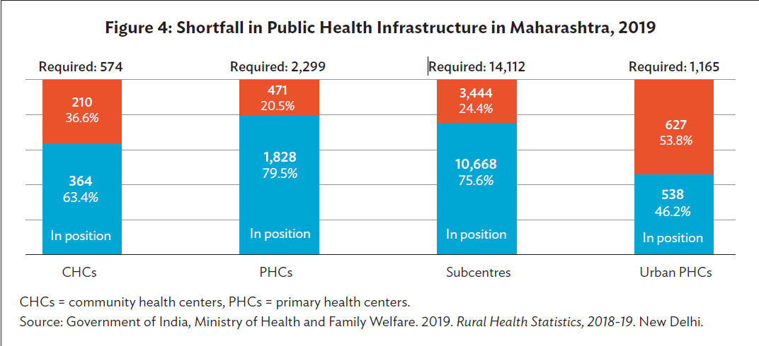

Medical and Public Health Officer Posts and Vacancies in Maharashtra, 2020

PRIVATE HEALTH CARE INFRASTRUCTURE IN MAHARASHTRA
Division | Number of Hospitals | Bed Capacity | Bed Capacity per ‘000 Population | Intensive Care Unit Beds | ICU Beds (%) | Empaneled (PMJAY-MJPJAY) | Empaneled (%) | Excluded (%) | Total (reports not received)
Konkan | 310 | 23,697 | 1.47 | 2,864 | 12 | 145 | 47 |  | Mumbai, Suburban, and Raigad
Pune | 1,048 | 27,932 | 1.16 | 2,233 | 8 | 127 | 12
Nashik | 380 | 11,289 | 0.64 | 1,012 | 9 | 46 | 12 |  | Dhule
Aurangabad | 1,844 | 27,731 | 1.61 | 1,823 | 7 | 77 | 4 |  | Parbhani
Amravati | 446 | 8,231 | 0.70 | 544 | 7 | 20 | 4
Nagpur | 282 | 9,165 | 0.73 | 1,026 | 11 | 26 | 9
All MH | 4,310 | 108,045 | 1.09 | 9,502 | 9 | 441 | 10
Notes:
- Av/H = average beds per hospital, MH = Maharashtra, PMJAY-MJPJAY = Pradhan Mantri Jan Arogya Yojana and Mahatma Jyotiba Phule Jan Arogya Yojana.
- Reports from excluded districts were not available at the time of tabulation in June 2020.
- Source: Maharashtra Public Health Department. Clinical Establishment Registration Data from Districts.

Nurse and Doctor Production Ratio, and Intake to Population Ratio for Maharashtra , 2016

elopment Board | Population (2011) | Medical Colleges (Number) | Medical Colleges (Intake) | Nursing Colleges (Number) | Nursing Colleges (Intake) | Nurse and Doctor Production Ratio | Medical Colleges Intake to Population Ratio | Nursing Colleges Intake to Population Ratio
Rest of Maharashtra | 70,629,910 | 24 | 3,120 | 60 | 2,880 | 0.9 | 1:22,638 | 1:24,524
Marathwada | 18,731,872 | 06 | 700 | 21 | 960 | 1.37 | 1:26,760 | 1:19,512
Vidarbha | 23,012,551 | 08 | 1,100 | 19 | 800 | 0.73 | 1:20,921 | 1:28,766
Total | 112,374,333 | 38 | 4,920 | 100 | 4,640 | 0.94 | 1:22,840 | 1:24,219
Nursing Education Institutions and Admission Capacity in Maharashtra,2019

Region | Number of Institutions | Annual Admission Capacity
 |  | GNM + ANM | GNM | BSc(N) | MSc(N) | BSc(N)
Aurangabad | 140 | 2,900 | 1,665 | 1,010 | 25 | 2,675
Nagpur | 147 | 3,370 | 1,350 | 1,040 | 75 | 2,390
Pune | 122 | 2,705 | 2,285 | 2,180 | 305 | 4,465
Greater Mumbai | 4 | 100 | 555 | 555 | 69 | 1,110
Mumbai | 72 | 1,630 | 1,575 | 1,250 | 122 | 2,825
Total | 485 | 10,705 | 7,430 | 6,035 | 596 | 13,465

Notes:
- GNM + ANM: General Nurse Midwife + Auxiliary Nurse Midwife.
- BSc(N): BSc (Nursing) + Post Basic BSc (Nursing).
- MSc(N): MSc (Nursing).

Total Health Expenditure in Maharashtra and Selected States

 | Share of GSDP or GDP in Total Health Expenditure (%) |  |  | Per Capita Total Health Expenditure (₹ and $)
 | 2015 | 2016 | 2017 | 2015 | 2016 | 2017
Maharashtra | 3.0 | 2.8 | 2.9 | 4,502 (₹73.63) | 4,734 (₹72.31) | 5,210 (₹77.68)
Gujarat | 2.1 | 2.0 | 2.1 | 3,060 (₹50.05) | 3,332 (₹50.89) | 3,730 (₹55.61)
Madhya Pradesh | 3.9 | 3.8 | 3.4 | 2,511 (₹41.07) | 2,681 (₹40.95) | 2,820 (₹42.04)
Karnataka | 3.0 | 3.2 | 2.8 | 4,374 (₹71.54) | 4,936 (₹75.40) | 5,183 (₹77.28)
Tamil Nadu | 2.8 | 2.8 | 2.8 | 4,101 (₹67.07) | 4,339 (₹66.28) | 4,734 (₹70.58)
Kerala | 4.8 | 4.5 | 4.5 | 6,801 (₹111.23) | 7,169 (₹109.50) | 8,083 (₹120.51)
All India | 3.9 | 3.8 | 3.8 | 3,826 (₹62.57) | 4,116 (₹62.87) | 4,381 (₹65.32)

GDP = gross domestic product, GSDP = gross state domestic product.
Note: to $ rate for respective fiscal years from Table 140 in Reserve Bank of India (2020).
Sources: Reserve Bank of India. 2020. Handbook of Statistics on the Indian Economy, 2019–20. Mumbai; Government of India,
Ministry of Health and Family Welfare. National Health Accounts Estimates for India, 2004–05, 2013-14, 2014–15, 2015–16, and
2016–17. New Delhi: National Health Accounts Technical Secretariat, National Health Systems Resource Centre.

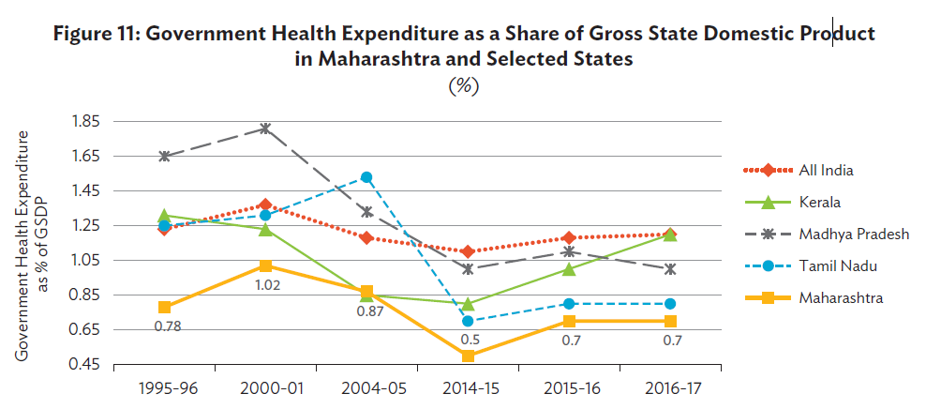

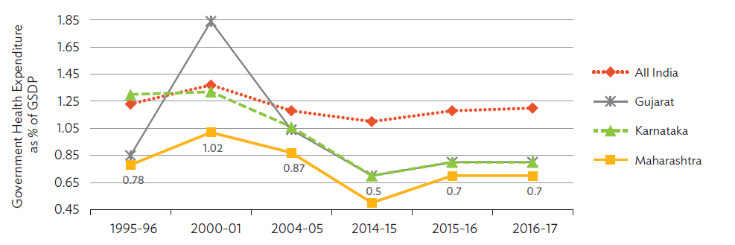

GSDP = gross state domestic product.
Notes:
1. The data has been plotted into two charts to avoid overlap and for clearer visibility. The all-India average and
Maharashtra data are plotted in both upper and lower charts for easy comparison.
2. 1995/96, 200/01, and 2004/05 data are from National Institute of Public Finance and Policy (2008), the rest from the
National Health Systems Resource Centre under the Ministry of Health and Family Welfare.
Sources: National Institute of Public Finance and Policy. 2008. Inter-State Equalisation of Health Expenditures in Indian
Union. New Delhi; Government of India, Ministry of Health and Family Welfare, National Health Accounts Technical
Secretariat, National Health Systems Resource Centre.
2)
Gender differentials in cognitive frailty among older adults in India: a multivariate decomposition approach

The study presented in the document focuses on cognitive frailty among older adults in India, utilizing data from the Longitudinal Aging Study in India (LASI). Here’s a detailed summary of the key aspects of the research:

Background
Cognitive frailty is a condition that combines physical frailty and cognitive impairment, significantly impacting the health and well-being of older adults. Understanding its prevalence and the factors contributing to it is crucial for developing effective health interventions.

Data Source
The research utilized data from the first wave of the LASI, conducted between April 2017 and December 2018. This large-scale longitudinal survey is representative at both national and state levels, focusing on individuals aged 45 and above, including their spouses. The survey collected comprehensive data on various aspects of health, social security, and economic well-being, with ethical approval from the Indian Council of Medical Research (ICMR) 3, 3.

Sample Size
The analytical sample consisted of 28,935 individuals aged 60 and above, with a near-equal distribution of males (13,946) and females (14,989). Individuals below 60 were excluded to focus specifically on older adults. The dependent variable, cognitive frailty, was assessed using anthropometric measurements, and those with incomplete data were excluded from the analysis 3.

Methodology
  - Statistical Analysis: The study employed bivariate analysis to estimate the observed prevalence of cognitive frailty, using proportion tests to evaluate gender differentials. Multivariate logistic regression was utilized to identify factors associated with cognitive frailty, adjusting for various explanatory variables. The odds ratios (both unadjusted and adjusted) were calculated to understand the relationship between these factors and cognitive frailty 6.
  - Decomposition Analysis: A multivariate decomposition analysis was conducted to explore the contributions of different covariates to the observed differences in cognitive frailty between genders. This analysis distinguished between compositional differences (endowments) and the effects of characteristics (coefficients) 6.

Key Findings
  - The study found a prevalence of cognitive frailty at 4.4% among the older adult population.
  - Significant gender differences were observed, with higher rates of cognitive frailty in females compared to males.
  - Various factors, including socio-economic status, health behaviors, and demographic characteristics, were identified as influencing cognitive frailty.

Conclusion
The findings underscore the importance of addressing cognitive frailty in older adults, particularly among women, to improve health outcomes. The study highlights the need for targeted interventions and policies to support cognitive health in aging populations.

Acknowledgments
The authors contributed to the study's conception, design, analysis, and manuscript preparation, with no external funding received for the research. Ethical considerations were adhered to, as the study involved secondary data analysis without direct participant interaction 17.
This summary encapsulates the study's objectives, methodology, and findings, providing a comprehensive overview of the research on cognitive frailty among older adults in India.
What are the key findings regarding the prevalence of cognitive frailty among older adults in India?
The key findings regarding the prevalence of cognitive frailty among older adults in India, as reported in the study, are as follows:
  - Overall Prevalence: The study found that the overall prevalence of cognitive frailty among older adults in India was 4.4%.
  - Gender Differences: There was a significant gender disparity in the prevalence of cognitive frailty:
    - Older Males: 2.1% (95% Confidence Interval: 1.8–2.3) of older males were identified as cognitively frail.
    - Older Females: 6.4% (95% Confidence Interval: 6.0–6.8) of older females were identified as cognitively frail.
    - This indicates a notable difference of 4.3% (p-value < 0.001) between the genders, with women exhibiting a higher prevalence of cognitive frailty compared to men.
  - Contributing Factors: The study identified several factors associated with an increased risk of cognitive frailty, including:
    - Age: Older age was linked to a higher prevalence of cognitive frailty.
    - Gender: Being female was associated with a higher likelihood of cognitive frailty (Adjusted Odds Ratio: 1.61; 95% CI: 1.33–1.95).
    - Socioeconomic Factors: Lower educational status and being out-of-wedlock were also significant risk factors.
    - Health Status: Poor self-rated health and underweight status were associated with cognitive frailty.
    - Mental Health: Depression was prevalent among participants with cognitive frailty.
  - Impact of Education: The study suggested that the considerable gender gap in cognitive frailty prevalence could be reduced by improving educational access for women, estimating a 37% reduction if women had similar education levels as men.
These findings highlight the critical need for gender-sensitive interventions and policies aimed at addressing cognitive frailty, particularly among older women in India 11, 1.

How does the study define "cognitive frailty," and why is it significant in geriatric health?

The study defines "cognitive frailty" as the co-existence of physical frailty and cognitive impairment without dementia. This concept encompasses both physical and cognitive dimensions of health, reflecting a more comprehensive understanding of frailty in older adults. Specifically, cognitive frailty includes the following components:
  - Physical Frailty: Defined by the presence of at least three out of five specific criteria based on the Fried criteria, which are:
    - Unintentional weight loss
    - Slow walking speed
    - Muscle weakness
    - Low physical activity
    - Exhaustion
  - Cognitive Impairment: This refers to a decline in cognitive function that affects daily living but does not reach the threshold for dementia.

Significance in Geriatric Health
The significance of cognitive frailty in geriatric health is multifaceted:
  - Increased Health Risks: Cognitive frailty is associated with a higher risk of adverse health outcomes, including falls, hospitalization, reduced quality of life, and increased mortality rates. It serves as a robust predictor for the development of dementia, particularly vascular dementia.
  - Complex Interplay of Factors: Understanding cognitive frailty allows for a better grasp of the complex interplay between physical and cognitive health in older adults. This dual focus is essential for identifying individuals at risk and implementing timely interventions.
  - Need for Comprehensive Care: Older adults experiencing cognitive frailty require more intensive care and support, which can place significant demands on family members and healthcare systems. Recognizing this condition is crucial for ensuring that appropriate care strategies are developed and implemented.
  - Gender Differences: The study highlights that men and women may experience cognitive frailty differently due to biological, social, and cultural factors. This understanding is vital for tailoring interventions that address the specific needs of different gender groups.
  - Policy Implications: Investigating cognitive frailty can inform public health policies and geriatric care practices, leading to the development of gender-sensitive interventions aimed at improving the overall quality of life for older adults.
In summary, the definition of cognitive frailty and its implications underscore the importance of addressing both physical and cognitive health in older adults to enhance their well-being and reduce the burden on healthcare systems 2, 2.
What methods were used to analyze gender differences in cognitive frailty in this research?
The research employed several methods to analyze gender differences in cognitive frailty among older adults in India:
  - Descriptive and Bivariate Analyses: The study began with descriptive statistics to summarize the characteristics of the sample population. Bivariate analyses were conducted to explore the relationship between gender and cognitive frailty, allowing for an initial assessment of differences in prevalence rates between males and females.
  - Proportion Test: A proportion test was utilized to assess gender disparities in cognitive frailty prevalence. This statistical test helped determine the significance of the differences observed between male and female participants.
  - Multivariate Decomposition Analysis: To further understand the extent to which various covariates contribute to explaining the observed gender differences in cognitive frailty, the study performed multivariate decomposition analysis. This method helps identify the specific factors (such as socioeconomic status, health determinants, and behavioral characteristics) that account for the differences in cognitive frailty prevalence between genders.
These methods collectively provided a comprehensive approach to analyzing gender differences in cognitive frailty, allowing the researchers to identify significant disparities and the underlying factors contributing to these differences 11, 1.

3)
A framework for human evaluation of large language models in healthcare derived from literature review
Healthcare applications of LLMs.
The reviewed studies showcased a diverse range of
healthcare applications for LLMs from bench to
bedside and beyond, each aiming to enhance different
aspects of patient care and clinical practice, biomedical
and health sciences research, and education.

Abstract
This document presents a framework for the human evaluation of large language models (LLMs) utilized in healthcare settings, derived from a review of 142 studies highlighting existing methodologies and gaps in evaluation practices. It proposes the QUEST framework, which identifies five key evaluation principles: Quality of Information, Understanding and Reasoning, Expression Style and Persona, Safety and Harm, and Trust and Confidence, structured across the phases of Planning, Implementation and Adjudication, and Scoring and Review. The evidence emphasizes the critical need for rigorous human assessment to ensure the reliability and safety of LLM applications in healthcare.

Key Points
- The study reviews human evaluation methodologies for large language models in healthcare, addressing issues with existing practices across 142 studies.
- It identifies significant gaps in reliability, generalizability, and applicability of current human evaluation practices for LLMs in medical contexts.
- The proposed QUEST framework consists of three phases—Planning, Implementation and Adjudication, and Scoring and Review—facilitating systematic evaluation processes.
- Five principles within the QUEST framework—Quality of Information, Understanding and Reasoning, Expression Style and Persona, Safety and Harm, and Trust and Confidence—guide evaluators in assessing LLMs.
- Healthcare applications of LLMs primarily focus on Clinical Decision Support, Medical Education, Patient Education, and Patient-Provider Question Answering, highlighting their diverse utility.
- The review notes a predominance of automated metrics in studies, pointing out the shortcomings in not assessing critical qualitative factors necessary for effective clinical deployment.
- A collaborative approach across disciplines is recommended to improve the robustness and transparency of LLM evaluations suited to healthcare environments.
The evaluation of large language model (LLM) outputs in healthcare is guided by the QUEST framework, which comprises five key principles, each with specific criteria. Here’s a detailed breakdown of these criteria:

Top 10 medical specialties. The literature review revealed a diverse range of  medical specialties leveraging LLMs, with Radiology the leading specialty. Urology  and General Surgery also emerged as prominent specialties, along with Plastic  Surgery, Otolaryngology, Ophthalmology, Orthopedic Surgery and Psychiatry, | while other specialties had fewer than 5 articles each. This distribution highlights the  broad interest and exploration of LLMs across various medical domains, indicating  the potential for transformative impacts in multiple areas of healthcare, and the need  for comprehensive human evaluation in these areas.

1. Quality of Information
This principle assesses the overall quality of the information provided by the LLM outputs. The specific criteria include:
- Accuracy: The correctness of the response, ensuring it is factually precise and free of errors.
- Relevance: The alignment of the response with the user's query, addressing the question without unnecessary information.
- Currency: The timeliness of the information, ensuring it reflects the most current knowledge, especially in rapidly evolving fields.
- Comprehensiveness: The completeness of the response, covering all critical aspects of the query.
- Consistency: The stability of responses across similar queries, ensuring uniform quality and accuracy.
- Agreement: The coherence of the response with established facts and theories, ensuring no contradictions.
- Usefulness: The applicability and utility of the response, ensuring it is actionable and relevant to the user's context.

Number of evaluation samples. The left panel shows the distribution of sample size for all studies while the right panel depicts the distribution for studies with
1–100 sample(s).

Number of human evaluators. The left panel shows the distribution of the number of human evaluators for all studies while the right panel depicts the distribution for
studies with 1–20 human evaluator(s).

2. Understanding and Reasoning
This principle evaluates the LLM's ability to comprehend and logically process information:
- Understanding: The ability of the LLM to interpret the user's query correctly.
- Reasoning: The capability of the LLM to apply logical processing to generate responses.

3. Expression Style and Persona
This principle focuses on the manner in which the LLM communicates:
- Clarity: The quality of the response should be clear and understandable.
- Empathy: The ability of the LLM to generate responses that reflect an understanding of the user's emotions or tone.

4. Safety and Harm
This principle assesses the potential risks associated with the LLM's outputs:
- Bias: The presence of systematic prejudices in the response, such as racial or gender bias.
- Harm: The potential for the response to lead to negative outcomes, including misinformation or reinforcement of stereotypes.
- Self-awareness: The LLM's recognition of its limitations and avoidance of speculation when lacking information.
- Fabrication, Falsification, or Plagiarism: The presence of made-up information, distorted facts, or uncredited text from other sources.

5. Trust and Confidence
This principle evaluates the user's trust in the LLM's outputs:
- Trust: The confidence in the LLM to provide accurate, fair, and safe responses.
- Satisfaction: The extent to which the LLM meets or exceeds user expectations regarding response quality and interaction experience.

Evaluation Process
The evaluation process involves several phases:
- Planning: Defining goals, tasks, stakeholders, and success criteria.
- Implementation and Adjudication: Conducting evaluations using trained human evaluators and statistical analysis to ensure reliability.
- Scoring and Review: Aggregating scores from evaluators and comparing them with automatic evaluation metrics for a comprehensive assessment.
By adhering to these criteria and processes, healthcare professionals can ensure that LLM outputs are reliable, safe, and effective for clinical applications.

To overcome such significant obstacles to healthcare LLM developments and deployments, we propose QUEST, a comprehensive and practical framework for human evaluation of LLMs covering three phases of workflow: Planning, Implementation and Adjudication, and Scoring and Review.

4)
A systematic review on using virtual assistance-based education and lifestyle interventions to prevent non-communicable diseases.

Summary of the Research Paper
Authors: Soumi Ray and Ankita Pareek (2023)
Objective: The study aims to explore the effectiveness of virtual assistance (VA) and digital health interventions (such as mobile health applications, virtual coaching, and wearable fitness devices) in managing and preventing non-communicable diseases (NCDs). NCDs, including cardiovascular diseases, diabetes, respiratory diseases, and cancer, are chronic, non-infectious illnesses that require long-term management.
Methodology: The authors conducted a systematic review of 21 articles from databases like PubMed, Embase, Google Scholar, and Scopus. They focused on studies published between 2015 and 2022 that included digital and virtual interventions for NCD management and prevention. The articles were selected based on their relevance to virtual health interventions, sample size, and research methodology. Both primary and secondary studies were included.

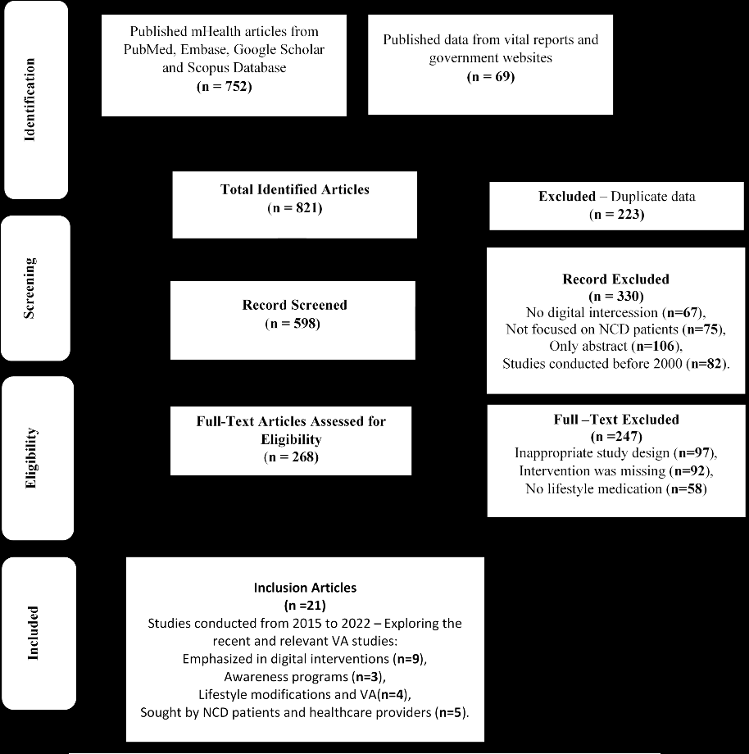

Key Findings and Statistics
- Geographical Focus:
  - 62% of the studies (13 out of 21) had an international focus, including high-income and low-middle-income countries (LMICs).
  - 38% of the studies focused specifically on India, reflecting the challenges and adoption of virtual health interventions in developing nations.
- Study Types:
  - 52% of the studies were secondary research, involving a review and descriptive analysis of existing data.
  - 38% of the studies were primary research, including randomized controlled trials and mixed-method studies, which provided new data on the effectiveness of VA in NCD management.
- Effectiveness of VA Interventions:
  - 38% of the studies (8 studies) concluded that VA interventions were highly effective for managing and preventing NCDs. These studies showed measurable improvements in patient health, increased engagement with healthcare systems, and sustainable lifestyle changes.
  - 47% of the studies (10 studies) suggested that VA could be effective but noted the need for further refinement. These refinements include improvements in tools, guidelines, and the development of sustainable public-private partnerships to maximize efficacy.
  - 14% of the studies (3 studies) indicated a need for a more practical, in-depth approach to determine VA effectiveness. They emphasized that additional large-scale studies are required to confirm the effectiveness and economic feasibility of VA-based interventions.
Geographic Locus (Region) of the Study.
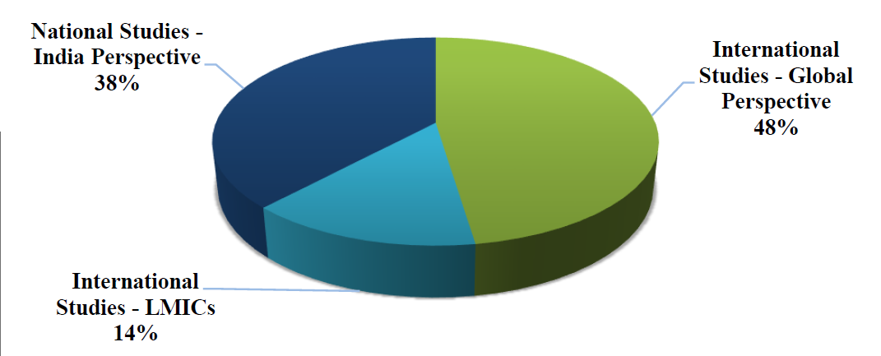
Amongst them, 13 studies (62%) provided the perception at the international level. Out of these, three studies (14%) portrayed low and middle-income nations. The eight studies (38%) were conducted in India, the majority in the southern belt of the country (Figure 2). | Amongst them, 13 studies (62%) provided the perception at the international level. Out of these, three studies (14%) portrayed low and middle-income nations. The eight studies (38%) were conducted in India, the majority in the southern belt of the country (Figure 2).

Study Types
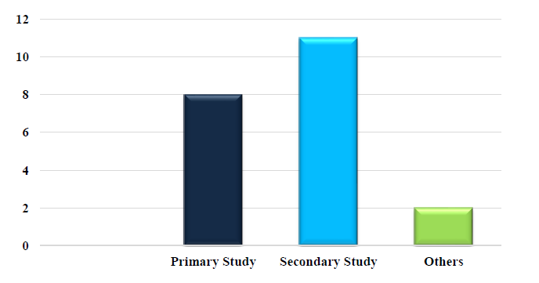
In the majority of the studies, the sample size is significantly small. The application of the intervention implied the effectiveness reflected (Figure 4); eight studies (38%) found that virtual assistance using the various modes has been highly effective for NCD patients. The ten studies (47%) implied that the method can be effective but requires refinements of tools, guidelines, incorporation of a suitable model (public-private partnership), and so on. The three studies (14%) revealed that a more pragmatic approach with in-depth studies is essential to come to any definite conclusion. | In the majority of the studies, the sample size is significantly small. The application of the intervention implied the effectiveness reflected (Figure 4); eight studies (38%) found that virtual assistance using the various modes has been highly effective for NCD patients. The ten studies (47%) implied that the method can be effective but requires refinements of tools, guidelines, incorporation of a suitable model (public-private partnership), and so on. The three studies (14%) revealed that a more pragmatic approach with in-depth studies is essential to come to any definite conclusion.

Additional Insights and Interpretation of Statistics
- Cost-Effectiveness: VA-based interventions were highlighted as cost-effective, especially in developing countries where healthcare resources are limited. The studies pointed out that virtual assistants could reduce long-term healthcare costs by improving patient adherence to treatment and preventive measures.
- Limitations:
  - Small sample sizes were noted as a limitation in many studies, making it challenging to generalize findings across diverse populations.
  - While many studies showed positive outcomes, some studies recommended further research to explore long-term effectiveness and the integration of VA systems with traditional healthcare.

1. Role of Virtual Assistance (VA) in NCD Management and Prevention
- Accessibility and Engagement: The paper emphasizes that virtual assistance has improved patient accessibility to health services and lifestyle education, especially in remote areas and low-resource settings. VA tools such as mobile health (mHealth) apps and wearables allow for continuous monitoring, which enhances engagement by enabling patients to track their health metrics regularly.
- Self-Management and Education: VA systems are especially valuable for promoting self-management among NCD patients. Many interventions provide personalized reminders, feedback on lifestyle choices, and educational content on health management, which empower patients to make informed decisions.
- Technological Components: The use of advanced technologies, including artificial intelligence (AI) in digital health apps, enables better data analysis and provides predictive insights to improve preventive care. These technologies help in personalizing patient care, offering real-time advice based on the individual’s health data.

2. Challenges in Implementing VA Interventions for NCDs
- Data Privacy and Confidentiality: A major challenge highlighted is ensuring the privacy and confidentiality of patients’ health data. Since VA interventions involve sensitive personal data, robust cybersecurity measures and data protection laws are essential to build user trust.
- Economic and Infrastructure Barriers: In low- and middle-income countries, the affordability of digital health devices, internet access, and the general infrastructure for implementing these interventions are major barriers. Without public funding or subsidies, many patients may not benefit from these technologies.
- Interoperability with Existing Healthcare Systems: Integrating VA interventions with traditional healthcare systems remains a challenge. In settings where patients rely on a combination of digital and in-person care, seamless data sharing across platforms is needed to avoid redundancy and ensure cohesive care.
- User Adaptation and Digital Literacy: The effectiveness of VA interventions depends heavily on user familiarity with digital platforms. Older adults and low-literacy populations may face challenges in adopting VA systems, highlighting a need for simplified designs and user education.

3. Potential Impact of VA on Health Outcomes and Cost Savings
- Preventive Focus: The paper stresses the potential of VA systems to lower the incidence of NCDs through preventive education. By providing real-time feedback on lifestyle choices, these tools can guide users toward healthier habits and reduce their risk of developing NCDs.
- Cost-Effectiveness in Healthcare: VA interventions could lead to significant cost savings for healthcare systems, particularly by reducing hospital visits, facilitating early intervention, and decreasing dependency on in-person consultations. In the long term, this would alleviate the economic strain on healthcare systems, especially in countries struggling with high NCD-related expenses.

4. Future Research and Development Needs
- Refinement of Tools and Guidelines: Many studies within the review suggested that VA tools need further refinement to maximize their effectiveness. This includes enhancing AI-driven health monitoring features and creating more tailored educational content that aligns with users’ cultural contexts and health literacy levels.
- Large-Scale Trials and Longitudinal Studies: To establish stronger evidence, there is a need for large-scale, longitudinal studies that assess VA’s effectiveness over extended periods. This would help determine if the initial benefits observed in small trials hold up across more diverse populations and settings.
- Public-Private Partnerships: The paper suggests that collaboration between public health agencies and private technology companies could facilitate the development and implementation of these technologies at scale. Public-private partnerships could help address financial barriers, improve service reach, and ensure the sustainability of VA-based NCD interventions.

5. Policy and Regulatory Recommendations
- Data Protection Policies: Given the sensitivity of health data, policies focused on data protection and patient confidentiality are essential. Establishing clear data use and sharing guidelines will ensure VA tools can be safely implemented in a way that protects patient rights.
- Standardization and Certification of VA Tools: To ensure quality and efficacy, the paper calls for standardization in the development of VA tools. Certification processes could help verify that these tools meet necessary health standards and are effective in NCD management and prevention.

Overall Insights
This paper shows that virtual assistance has the potential to transform NCD management by promoting healthier behaviors, improving patient access to care, and reducing costs. However, it underscores the importance of a strategic approach that includes refining technology, improving healthcare infrastructure, and securing the necessary regulatory support. By addressing these areas, VA interventions could become a core component of NCD prevention and management in both developed and developing countries.

Conclusion
The paper concludes that VA-based interventions have strong potential for NCD prevention and management. They can be accessible, cost-effective, and widely accepted if implemented with the right infrastructure, guidelines, and partnerships. However, more comprehensive studies are necessary to address gaps, such as tool refinement and the need for long-term outcome data.
In summary, while VA shows promise, ensuring effectiveness on a larger scale will require refined tools, clear guidelines, and well-defined operational standards.

5 )
Non-communicable diseases, digital education and considerations for the Indian context – a scoping review

Anup Karan1, Suhaib Hussain1*, Lasse X Jensen2, Alexandra Buhl2, Margaret Bearman3 and Sanjay Zodpey1

Abstract
Introduction The increasing ageing of the population with growth in NCD burden in India has put unprecedented pressure on India’s health care systems. Shortage of skilled human resources in health, particularly of specialists equipped to treat NCDs, is one of the major challenges faced in India. Keeping in view the shortage of healthcare professionals and the guidelines in NEP 2020, there is an urgent need for more health professionals who have received training in the diagnosis, prevention, and treatment of NCDs. This paper conducts a scoping review and aims to collate the existing evidence on the use of digital education of health professionals within NCD topics.

Methods We searched four databases (Web of Science, PubMed, EBSCO Education Research Complete, and PsycINFO) using a three-element search string with terms related to digital education, health professions, and terms related to NCD. The inclusion criteria covered the studies to be empirical and NCD-related with the target population as health professionals rather than patients. Data was extracted from 28 included studies that reported on empirical research into digital education related to non-communicable diseases in health professionals in India. Data were analysed thematically.

Results The target groups were mostly in-service health professionals, but a considerable number of studies also included pre-service students of medicine (n = 6) and nursing (n = 6). The majority of the studies included imparted online learning as self-study, while some imparted blended learning and online learning with the instructor. While a majority of the studies included were experimental or observational, randomized control trials and evaluations were also part of our study.

Discussion Digital HPE related to NCDs has proven to be beneficial for learners, and simultaneously, offers an effective way to bypass geographical barriers. Despite these positive attributes, digital HPE faces many challenges for its successful implementation in the Indian context. Owing to the multi-lingual and diverse health professional ecosystem in India, there is a need for strong evidence and guidelines based on prior research in the Indian context.

Keywords Health professions education, Non-communicable diseases (NCD), India, Digital education, Scoping review

6 )
Estimates of major non-communicable disease risk factors for India, 2010 & 2015: A summary of evidence

Research Background and Objectives
The study, led by researchers from India’s top health institutions, aimed to provide estimates for the prevalence of major non-communicable disease (NCD) risk factors in India for 2010 and 2015. This was important for tracking India's progress toward the national targets established for reducing NCD risk factors.

Methodology Summary
- Data Collection and Sources:
  - Researchers used systematic literature review methods to gather data on specific NCD risk factors (like tobacco and alcohol use, physical inactivity, obesity, and raised blood pressure) in India.
  - They focused on studies and reports published between 2008 and 2017. Major databases like PubMed, Google Scholar, and Cochrane were used, along with national survey reports.
  - For inclusion, studies had to be conducted within the 18-69 age range and provide data on the defined NCD risk factors. Only community-based and cross-sectional studies, as opposed to institutional or subgroup-specific studies, were included.
- Screening and Selection Process:
  - Researchers followed Preferred Reporting Items for Systematic Reviews and Meta-Analyses (PRISMA) guidelines to screen studies. From thousands of initial results, they included studies that matched the NCD focus.
  - In total, 84 studies contributed data for 2010, and 45 studies contributed to 2015 estimates.
- Risk Factor Definitions:
  - Definitions aligned with the World Health Organization (WHO) recommendations for consistency. For instance:
    - Raised blood pressure: Defined as ≥140/90 mmHg.
    - Physical inactivity: Defined as less than 150 minutes of moderate activity or 75 minutes of vigorous activity per week.
    - Tobacco and alcohol consumption: Measured as the percentage of people who used these substances in the past year.
- Data Extraction and Strata-Based Analysis:
  - Data were stratified by age (18-44 and 45-69), gender (male and female), and place of residence (urban and rural) to capture the diversity of India's population.
  - Meta-analysis was then conducted within each stratum using MetaXL software, pooling prevalence data with a random effects model for 2010 and 2015 separately. Each stratum's estimates were weighted based on national census data to produce national prevalence estimates for each risk factor.
- Credibility Assessment:
  - Researchers evaluated the estimates' credibility based on four factors:
    - Study Quality: Assessed with the Joanna Briggs Institute (JBI) tool.
    - Representativeness: Geographical coverage across six Indian zones.
    - Precision: Using confidence interval width relative to the estimate.
    - Stability: Comparison between 2010 and 2015 estimates to check consistency.

Statistical Analysis and Interpretation
- The national estimates were derived by pooling data across different studies, applying population weights to reflect the actual demographics.
- The analysis identified significant changes in risk factors like tobacco use, which declined by 18.5%, and physical inactivity, which dropped by 15.6%.
- The estimates were validated by comparing them with national and global data from similar periods.

Key Findings
The study highlighted both positive trends (like a decrease in tobacco use and physical inactivity) and stable or negligible changes in alcohol use and obesity rates. This methodology provided a robust basis for tracking NCD risk factors in India and underlined the importance of tailored, ongoing data collection to measure public health progress.
This structured and rigorous approach helped ensure that the estimates were credible and could inform India’s health policy on NCD prevention and management​

The study provided specific prevalence estimates for major non-communicable disease (NCD) risk factors in India for the years 2010 and 2015. Here is a breakdown of the key data from the study:

Prevalence Estimates for NCD Risk Factors in India
Risk Factor | 2010 National Estimate (95% CI) | 2015 National Estimate (95% CI) | Observations/Changes
Current Alcohol Use | 15.7% (13.2 - 18.2) | 15.6% (13.5 - 17.7) | Minimal change, consistently higher in men.
Current Tobacco Use | 27.0% (21.4 - 32.6) | 22.0% (17.3 - 26.6) | Relative decline of 18.5%; urban areas and men showed larger reductions.
Physical Inactivity | 44.2% (37.8 - 50.6) | 37.3% (32.7 - 41.9) | Decline of 15.6%; more significant in urban areas, with rural areas showing increased inactivity.
Solid Fuel Use for Cooking | 61.5% (50.2 - 72.5) | 55.7% (41.6 - 69.8) | Modest decline; rural areas have a higher prevalence of solid fuel use.
Raised Blood Pressure | 20.2% (18.4 - 22.1) | 21.6% (19.3 - 23.9) | Slight increase; men and urban areas showed higher prevalence.
Overweight | 20.5% (12.6 - 28.4) | 21.7% (18.0 - 25.4) | Small increase; higher in urban residents.
Obesity | 7.0% (3.8 - 10.2) | 7.7% (5.4 - 10.1) | Minimal change; more prevalent in urban areas.

Additional Observations
- Gender and Urban-Rural Differences: Men had higher prevalence rates of alcohol and tobacco use, while urban residents exhibited higher levels of obesity and physical inactivity.
- Consistency and Precision: The estimates showed moderate-to-high credibility based on representativeness, stability, and precision, but some limitations were noted, such as lower precision in stratified rural data.

Conclusion
The study's data revealed positive shifts in tobacco use and physical inactivity but also underscored the need for further interventions in areas with minimal change, such as alcohol use and raised blood pressure. These findings provide valuable benchmarks for tracking India’s NCD control progress.
Let me know if you'd like more detailed breakdowns by demographics or further analysis.
the study highlighted several critical insights that go beyond the specific prevalence numbers. These are important for understanding the broader implications of NCD risk factors and the effectiveness of national health initiatives in India.

1. Impact of National Initiatives and Policy Gaps
- Tobacco Control: The study observed a significant reduction in tobacco use from 2010 to 2015, which aligns with India’s strong tobacco control policies under the National Tobacco Control Programme (NTCP) and the Framework Convention on Tobacco Control (FCTC). This highlights the effectiveness of national campaigns, increased taxation, and restrictions on tobacco advertising.
- Alcohol Policy: Unlike tobacco, the prevalence of alcohol use remained relatively stable, possibly due to the lack of a strong, comprehensive national alcohol control policy. The study suggests that the erratic implementation of state-level alcohol policies could be a limiting factor.

2. Socioeconomic and Geographical Disparities
- Urban-Rural Divide: Urban areas showed higher rates of physical inactivity, overweight, and obesity, likely due to more sedentary lifestyles and dietary changes. In contrast, rural areas exhibited higher rates of solid fuel use for cooking, reflecting limited access to clean energy.
- Gender Differences: Men had higher prevalence rates of alcohol and tobacco use, while women had higher levels of physical inactivity, suggesting that interventions might need to be tailored by gender.

3. Policy Implications and Intervention Needs
- The study emphasized that certain areas, like access to clean cooking fuels, saw improvements but still require significant attention, especially in rural areas. The Pradhan Mantri Ujjwala Yojana (PMUY), launched in 2016, was intended to address this issue but faced implementation challenges.
- Physical Activity Promotion: While physical inactivity decreased, it was still high, especially in urban areas. The study suggests the need for more community-based interventions promoting physical activity across urban and rural areas. India currently lacks robust policies for physical activity promotion, especially in rural settings.

4. Limitations and Future Research Needs
- Data Collection: The study highlights the need for a sustainable surveillance system to regularly collect NCD risk factor data. India conducted its first national NCD monitoring survey in 2017-18, but ongoing data collection will be crucial for accurate tracking and evaluation.
- Credibility and Gaps in Evidence: The estimates were generally credible, but some categories, such as obesity and overweight prevalence, showed limitations in precision due to data gaps at the national level.

5. Long-Term Outlook
- The study underscores that while India is progressing towards its 2025 NCD targets, certain areas, especially alcohol consumption and raised blood pressure, require stronger interventions. Increased awareness, combined with policy changes and public-private partnerships, could further enhance progress.

Conclusion
The study’s comprehensive analysis provides not only a snapshot of NCD risk factor trends but also actionable insights for policymakers. It underlines the need for targeted, sustained efforts across various socioeconomic groups to meet India’s NCD reduction goals effectively by 2025.
The researchers conducted a systematic study to estimate the prevalence of major non-communicable disease (NCD) risk factors in India for 2010 and 2015. Here’s a detailed look at their methodology:

1. Objective and Scope
- The goal was to estimate national prevalence rates for specific NCD risk factors (such as alcohol and tobacco use, physical inactivity, obesity, and raised blood pressure) across various demographics in India.
- The study aimed to provide baseline data for 2010 and 2015, which would enable monitoring progress toward India’s NCD reduction targets.

2. Data Collection and Sources
- Systematic Literature Review: The team conducted an extensive search of studies published between 2008 and 2017 in databases including PubMed, Google Scholar, and Cochrane.
- National and Large-Scale Surveys: In addition to academic studies, the researchers gathered data from large-scale national surveys and reports to get comprehensive national and subnational data.
- Risk Factors Examined: The study focused on specific risk factors with well-defined indicators, such as:
  - Tobacco and alcohol consumption
  - Physical inactivity
  - Obesity and overweight
  - Raised blood pressure
  - Solid cooking fuel use

3. Study Inclusion and Exclusion Criteria
- Inclusion Criteria: Studies were included if they:
  - Were conducted in India between 2008 and 2017.
  - Focused on participants aged 18-69 years.
  - Provided data on the specific NCD risk factors using definitions aligned with WHO standards.
  - Were community-based, cross-sectional, or prevalence studies.
- Exclusion Criteria: Studies that were policy papers, case-control studies, focused on specific subgroups (e.g., occupation-specific), or used definitions other than WHO’s were excluded.

4. Screening and Data Extraction
- Researchers followed Preferred Reporting Items for Systematic Reviews and Meta-Analyses (PRISMA) guidelines to systematically screen studies for inclusion.
- The data extracted included study details such as publication date, design, population demographics, and risk factor prevalence.

5. Stratification and Meta-Analysis
- Stratification by Demographics: To capture population diversity, the data were stratified by:
  - Age groups (18-44 years and 45-69 years)
  - Gender (male and female)
  - Residence (urban and rural)
- Meta-Analysis for Pooled Estimates:
  - The researchers used MetaXL software to conduct meta-analyses within each stratum, using a random effects model to account for study variability.
  - They calculated pooled prevalence estimates for each risk factor for both 2010 and 2015.

6. Weighting and National Estimates
- After obtaining strata-specific prevalence rates, the researchers combined them to derive national estimates.
- Population Weighting: Each stratum’s prevalence was weighted based on India’s census data from 2011 to create population-adjusted national prevalence estimates.

7. Credibility Assessment of Estimates
- To ensure the robustness of their findings, the researchers assessed the credibility of the estimates using four criteria:
  - Study Quality: Evaluated using the Joanna Briggs Institute (JBI) tool for prevalence studies.
  - Representativeness: Assessed based on the geographic spread of studies across India’s six regions.
  - Precision: Measured by the width of the confidence interval relative to the estimate.
  - Stability: Determined by comparing consistency in estimates between 2010 and 2015 across demographic groups.

8. Data Analysis and Interpretation
- Prevalence Trends: The estimates for each risk factor were analyzed for trends over time (2010 vs. 2015) and across demographic subgroups.
- Comparison with National and Global Data: To validate findings, the researchers compared their estimates with data from other national and international sources, such as the Global Burden of Disease study.

Key Results and Implications
This methodology allowed the researchers to provide credible and reliable prevalence estimates for NCD risk factors in India, identifying both progress (like reductions in tobacco use and physical inactivity) and areas needing improvement (such as consistent alcohol consumption levels and solid cooking fuel use in rural areas).

Conclusion
The study’s methodical approach provided a reliable baseline and trend data to support national NCD control strategies in India. This research model is crucial for continuous monitoring and effective policy planning.

7 )
Artificial Intelligence Solutions to Increase Medication Adherence in Patients With Non-communicable Diseases

LINK

- AI Technologies for Adherence:
  - Mobile Phone Applications: AI-driven apps with reminders, facial recognition, and ingestion verification improved adherence by up to 67%.
  - Reminder Systems: SMS-based conversational AI significantly increased refill rates.
  - Patient Empowerment: AI chatbots like "Vik" enhanced adherence by offering personalized support.
  - Integrated Care: AI facilitated multidisciplinary care, optimized prescriptions, and reduced medication errors.
  - Machine Learning: Predictive models identified adherence patterns and their impact on clinical outcomes.
- Benefits:
  - Improved adherence leads to better clinical outcomes (e.g., reduced hospitalization).
  - Saves healthcare professionals’ time by automating routine tasks.
  - Enables precision medicine through big data analysis.
- Challenges:
  - Patient Characteristics: Digital literacy, socioeconomic factors, and trust issues affect AI adoption.
  - Depersonalization Concerns: Potential loss of human connection in healthcare.
  - Infrastructure and Cost: High costs and lack of training hinder AI adoption.
  - Ethical Concerns: Data privacy, transparency, and inequality risks.
- Current Research Gaps:
  - Limited studies on AI’s long-term impact on adherence.
  - Insufficient research in low- and middle-income countries.
  - Lack of standardized measures for adherence data.
- Conclusion:
  - AI has potential for improving adherence in NCDs but faces barriers like ethics, infrastructure, and user engagement.
  - Future research should focus on diverse patient groups, long-term effectiveness, and cost-benefit analysis.

Data Analysis and Processing
- Data Sources: Electronic health records, clinical trials, and patient-reported data.
- AI Techniques: Machine learning algorithms for predictive modeling, natural language processing for clinical notes, and vision algorithms for ingestion verification.
- Outcomes Measured: Adherence rates, medication errors, and patient engagement metrics.

Datasets
- Specific datasets aren't mentioned in the paper but likely include anonymized patient records, trial data, and adherence tracking metrics (e.g., pharmacy refill rates, app usage logs).
Would you like detailed explanations of any section or further insights into the methodologies?

AI Solutions for Medication Adherence in NCDs
Overview:
The literature review highlights the critical role of artificial intelligence (AI) in addressing medication adherence challenges for patients with non-communicable diseases (NCDs). Non-adherence is a global health issue contributing to poor clinical outcomes and economic burdens. AI technologies are explored as innovative tools to monitor, predict, and improve medication adherence.

1. AI-Driven Mobile Applications
- Applications and Impact:
  - AI-powered mobile apps use features like reminders, facial recognition, and ingestion verification to monitor adherence.
  - Studies show that such apps improve adherence rates by up to 67%.
  - Real-time alerts and tailored notifications reduce forgetfulness and empower patient self-management.
- Examples in Literature:
  - Mobile adherence tools integrating AI have demonstrated significant improvements in clinical trials, particularly for chronic diseases like diabetes and hypertension.

2. Machine Learning Models for Adherence Prediction
- Applications and Impact:
  - Machine learning (ML) algorithms identify patterns in patient behavior and predict adherence risks using electronic health records (EHRs) and pharmacy refill data.
  - ML models aid in identifying high-risk patients for targeted interventions, reducing hospitalization and disease progression.
- Examples in Literature:
  - Predictive analytics has been used to link adherence behaviors with clinical outcomes, enhancing personalized medicine.

3. AI-Powered Reminder Systems
- Applications and Impact:
  - SMS-based AI systems improve medication adherence by delivering conversational reminders and follow-ups.
  - These systems enhance refill rates and create a sense of accountability.
- Examples in Literature:
  - A study showed significant improvement in refill adherence rates with AI SMS reminders for cardiovascular and diabetic patients.

4. AI-Enabled Patient Empowerment Tools
- Applications and Impact:
  - Chatbots and virtual assistants, like “Vik,” support patients by answering medication-related queries and offering personalized guidance.
  - These tools improve adherence by reducing patient doubts and fostering engagement.
- Examples in Literature:
  - Research highlights how conversational AI fosters trust and interaction, especially in managing polypharmacy.

5. AI in Multidisciplinary Care Integration
- Applications and Impact:
  - AI facilitates collaboration among healthcare providers to ensure optimal prescription management and error reduction.
  - Tools that integrate adherence monitoring with provider workflows improve coordination and outcomes.
- Examples in Literature:
  - Studies show that integrated AI systems reduce medication errors and support adherence in complex care environments.

6. Challenges and Gaps Identified in Literature
- Digital Divide: Limited digital literacy and access among vulnerable populations.
- Data Privacy Concerns: Ethical issues around patient data usage in AI systems.
- Limited Focus in LMICs: Few studies explore AI adherence solutions in low- and middle-income countries.
- Lack of Standardized Metrics: Absence of universal measures for evaluating adherence improvements.

Conclusion:
The literature supports the potential of AI in transforming adherence monitoring and improvement strategies. However, research gaps—such as long-term studies, standardization, and equity—must be addressed to maximize AI's impact on global health.
Would you like a deeper dive into specific areas or additional references for any particular aspect?
4o

You said:
I would like a deeper dive into this research paper

ChatGPT said:
ChatGPT
Let’s delve deeper into the research paper to provide a comprehensive understanding of its key elements, methodologies, findings, and implications.

Deeper Dive: Artificial Intelligence Solutions to Increase Medication Adherence in Patients With Non-Communicable Diseases

1. Problem Statement and Context
- Problem Addressed:
  - Non-communicable diseases (NCDs) like diabetes, cardiovascular diseases, and chronic respiratory conditions are leading global health issues.
  - Poor medication adherence is a major challenge, contributing to worsening health outcomes, increased mortality, and economic burdens.
- Role of AI:
  - AI offers innovative tools to address adherence barriers, such as forgetfulness, complex medication regimens, and lack of personalized healthcare support.

2. Objectives
- To review existing AI tools and techniques that improve medication adherence.
- To identify the benefits, challenges, and gaps in the current research landscape.
- To assess the applicability of AI in diverse healthcare settings.

3. Methodology
- Narrative Review Approach:
  - The paper systematically reviews studies related to AI solutions for medication adherence in NCDs.
  - Data sources include platforms like PubMed, Web of Science, and other peer-reviewed journals.
  - The focus is on AI applications, such as mobile apps, predictive models, and patient support systems.
- Key Criteria for Inclusion:
  - Studies demonstrating AI-driven interventions for adherence.
  - Applications specific to non-communicable diseases.
  - Evidence of clinical or behavioral outcomes linked to AI tools.

4. AI Technologies Explored
- Mobile Phone Applications:
  - AI apps monitor adherence through reminders, alerts, and ingestion verification.
  - Facial recognition and other verification technologies enhance reliability.
  - Result: Improved adherence rates in clinical trials (e.g., 67% improvement in some studies).
- Predictive Analytics with Machine Learning:
  - AI models identify patterns of non-adherence based on patient data.
  - Predictive tools enable proactive interventions by healthcare providers.
- AI-Powered Reminders:
  - SMS systems using conversational AI personalize reminders, increasing refill rates.
  - Example: Patients with cardiovascular conditions showed higher adherence with such interventions.
- Virtual Assistants and Chatbots:
  - Tools like "Vik" provide personalized guidance and education on medications.
  - Chatbots empower patients, reducing medication-related doubts and anxiety.
- Integrated AI in Multidisciplinary Care:
  - AI improves communication and coordination between healthcare teams.
  - Reduces prescription errors and streamlines adherence monitoring.

5. Key Findings
- Benefits of AI:
  - Improves adherence by addressing behavioral barriers (e.g., forgetfulness, lack of motivation).
  - Enhances patient engagement through personalized interactions.
  - Saves time for healthcare providers by automating routine tasks.
  - Promotes precision medicine through data analysis and tailored interventions.
- Challenges:
  - Infrastructure and Cost: Limited access to technology in low-resource settings.
  - Digital Literacy: Older adults and socioeconomically disadvantaged groups may struggle with AI tools.
  - Privacy Concerns: AI systems require robust mechanisms to protect patient data.
  - Ethical Issues: Transparency and fairness in AI decision-making need improvement.
- Research Gaps:
  - Lack of studies focusing on long-term adherence outcomes.
  - Limited research in low- and middle-income countries.
  - Absence of standardized metrics to measure AI’s impact on adherence.

6. Analysis of Data and Methodology
- Datasets:
  - Patient-reported adherence logs.
  - Pharmacy refill data.
  - Electronic health records (EHRs) with demographic, clinical, and behavioral data.
- Data Processing:
  - AI models trained on anonymized patient data to identify patterns of non-adherence.
  - Natural Language Processing (NLP) used for analyzing clinical notes and patient feedback.
  - Computer vision algorithms implemented in apps for ingestion verification.
- Evaluation Metrics:
  - Adherence rates (e.g., percentage of prescribed doses taken on time).
  - Patient satisfaction and engagement scores.
  - Reduction in hospital readmissions and medication errors.

7. Implications for Research and Practice
- For Healthcare Providers:
  - AI enables personalized care plans, enhancing patient outcomes.
  - Streamlines adherence monitoring, reducing the burden on healthcare professionals.
- For Patients:
  - Provides accessible tools for self-management of medications.
  - Increases awareness and motivation through interactive features.
- For Policymakers:
  - Highlights the need for investments in AI-driven healthcare tools.
  - Emphasizes the importance of ethical AI use and equitable access.

8. Conclusion
The paper concludes that AI has significant potential to address medication adherence issues in patients with NCDs. However, challenges like cost, privacy, and digital literacy need to be addressed for widespread adoption. Future research should focus on long-term effectiveness, diverse populations, and ethical frameworks to ensure equitable and impactful solutions.

8 )
mHealth initiatives for non-communicable disease (NCD"s) -a scoping review
of the Indian scenario

9)
A systematic review of associations between non-communicable diseases and socioeconomic status within low- and lower-middle-income countries

10 )
Patient and caregiver perspectives of select non-communicable diseases in India: A scoping review

11 )

Modifying Non‐communicable Disease Behaviours through Effective Health Communication and Behaviour Change: A Systematic Review

12 )

National Programme for Prevention and Control of Cancer, Diabetes, Cardiovascular Diseases, and Stroke: A Scoping Review in the Context of Hypertension Prevention and Control in India

13)

Feature selection and importance of predictors of non-communicable diseases medication adherence from machine learning research perspectives

14)
Raising burden of non-communicable diseases:
importance of integrating Yoga and Naturopathy
at primary care level

15)

Digital health innovations for non communicable disease management during the COVID-19 pandemic: a rapid scoping review

16)

.

* Non-communicable diseases in Indian slums: re-framing the Social Determinants of Health **

